GEOL 551: Applied Petroleum Geology   
Assignment #3 - Due 2/25/2019

Nadima Dwihusna

**Homework Task:**

* Have all logs correlated around section 21 (total of 9 blocks) & make 5 structure maps:

1. Top of D-Sandstone Map
2. Huntsman Shale Map
3. J Sandstone Map
4. X-Bentonite
5. Mowry

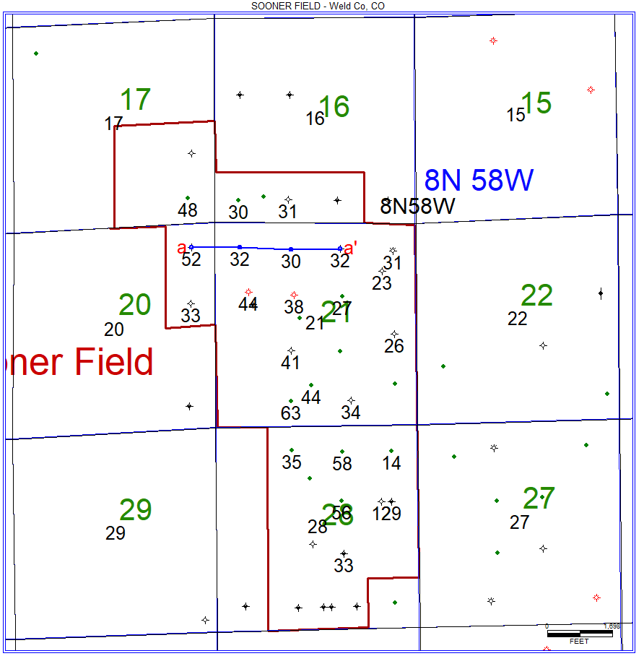

Figure 1: Map of all digital and raster logs to be correlated.

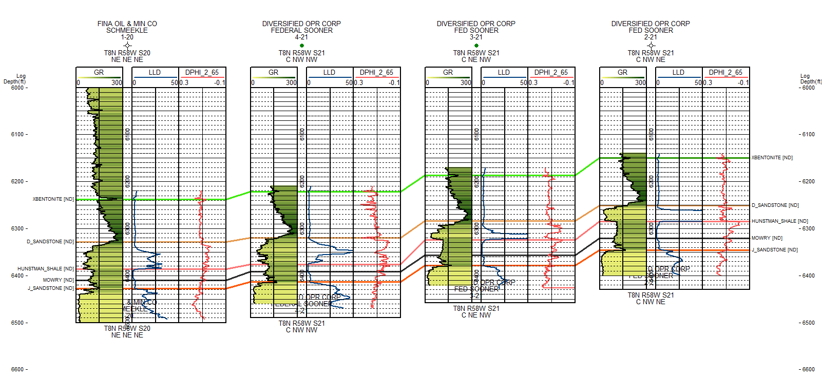

Figure 2: Digital Log Template

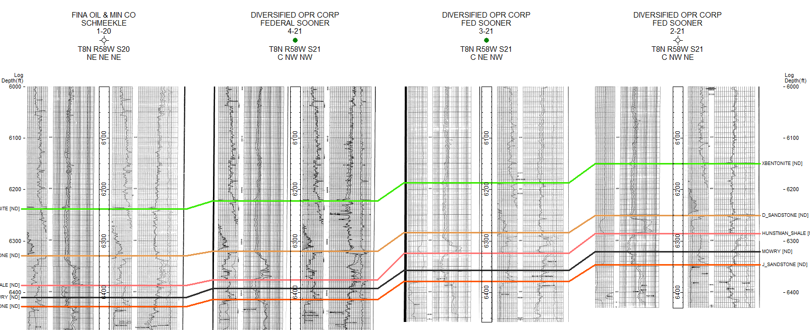

Figure 3: Raster Log Template

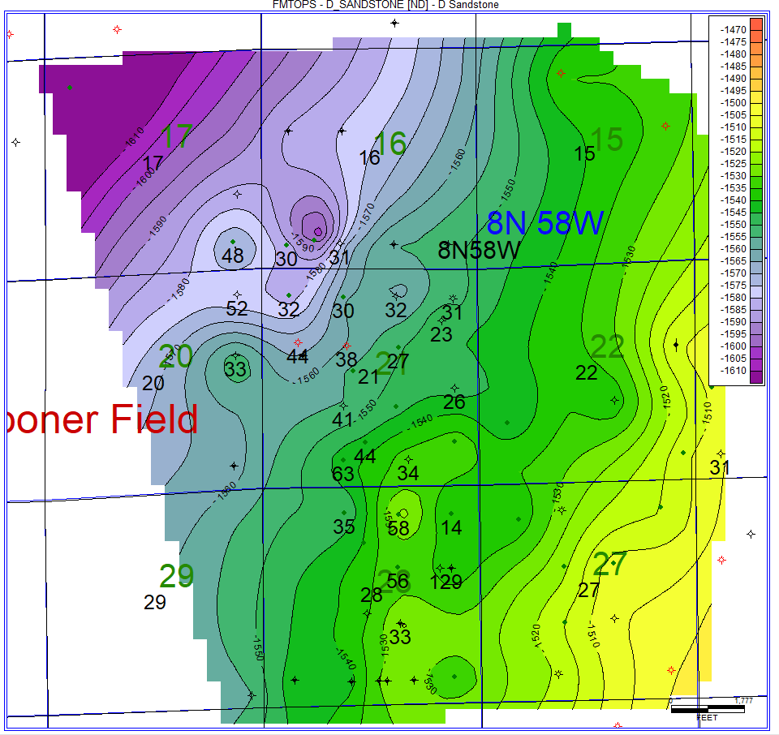

Figure 4: Top of D-Sandstone Map

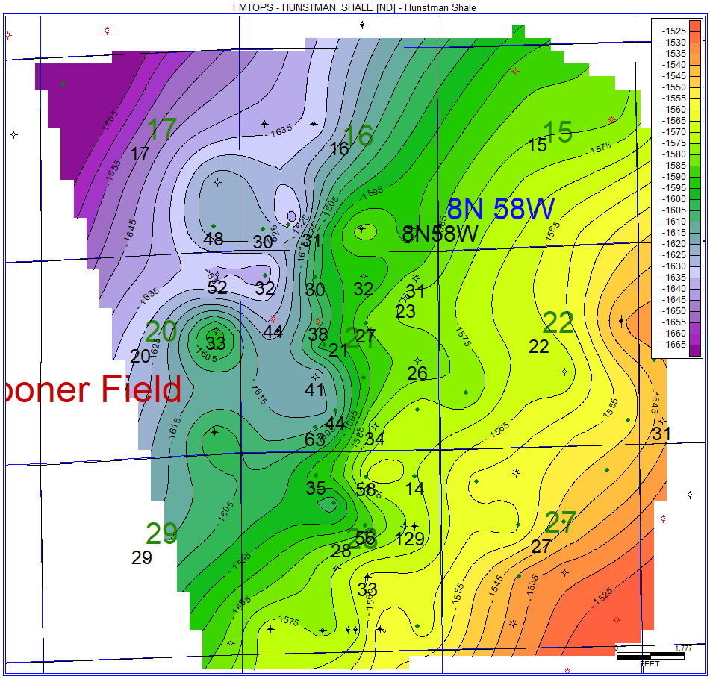

Figure 5: Huntsman Shale Map

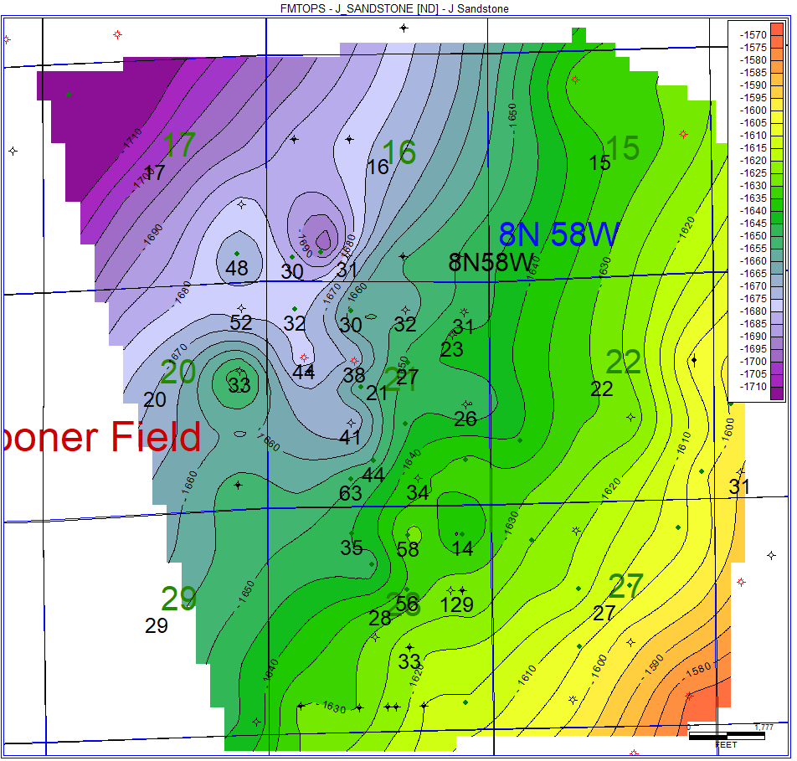

Figure 6: J Sandstone Map

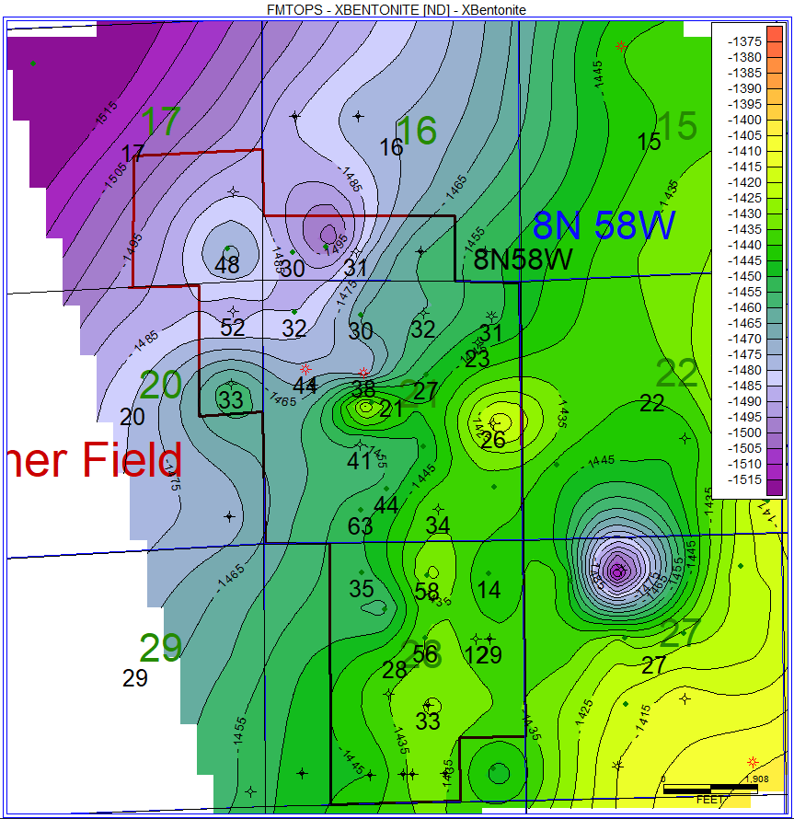

Figure 7: X-Bentonite Map

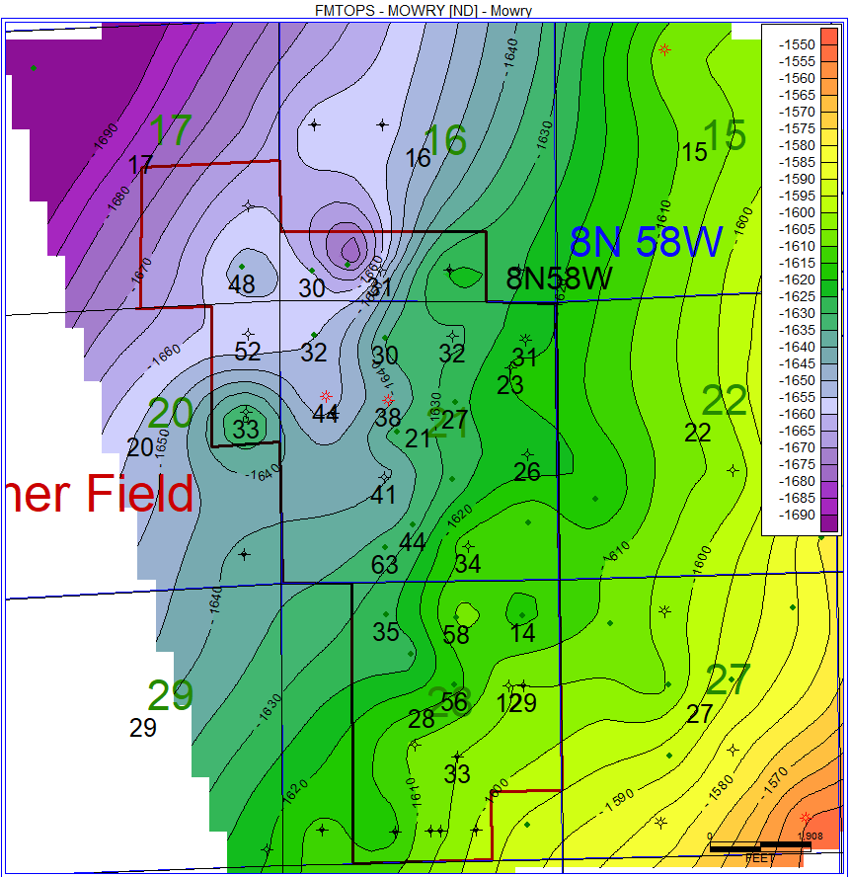

Figure 8: Mowry Map